**Biosensor Processing Package**

Version 2.0

*Chuangang Ren, Hunter Elliott*

**Overview**

This software is designed to process raw images from fluorescent biosensors into fully-corrected quantitative activation maps (ratio images). It assumes the images are standard 2D (widefield or single z-slice) fluorescence images of a ratiometric biosensor. Ratiometric biosensors use two image channels to determine the activity of interest: One channel is independent of the activity and gives the localization of the sensor, while the other varies in intensity with the activity the probe is designed to sense. These are referred to here as the ‘localization’ and ‘activation’ channels respectively. The localization channel is required when biosensors are imaged this way to separate variations in the concentration of the probe from variations in its measured activity. Because the comparison of the activation and localization channels is used to determine the magnitude and localization of the activity of interest, any difference between these two channels will be interpreted as a change in activation. Therefore, to ensure accurate measurement of activation, all other systematic differences between the channels must be eliminated. This requires several corrections to be applied to the images, which are described in more detail later on. When all corrections are applied and the activation and localization channels are ratioed, the result is a quantitative ‘ratio image’ of the location and magnitude of the activity of interest.

**Work flow of Biosensors Package:**

**New in Version 2.0**

* Process multiple movies at once, using the same settings and correction images
* Save groups of movies as “movie lists” for later re-processing, analysis with other software etc.
* Improved visualization of the results of each processing step.
* New tools for preparing your data for processing
* New tool for creating .avi or .mov movies from ratio images

**HOW TO USE THIS SOFTWARE:**

**The following is a step-by-step guide to using the software:**

**Step 1 – Acquire Your Data!**

**Experimental Data:**

Depending on the type of biosensor, different data will be required for processing. For unimolecular biosensors you will need only images of the activation signal and localization signal in each experiment, in addition to the correction images described below. For bimolecular biosensors, you may need additional images to correct for bleedthrough into the activation channel.

**Correction Images:**

To produce accurate, quantitative activation ratio images, several corrections are required. These corrections must be specific to the imaging system used to collect the raw data, and therefore require collection of “correction images.” These include:

**Dark-current images for each camera used**. These are images taken with the same exposure time but with *no light* incident on the CCD. This gives a measure of the magnitude and spatial variation of the camera’s noise.

**Shade/Illumination correction images for each channel imaged.** These are images taken with the same illumination, filters, exposure etc. as the experimental data, but taken of a blank area of a coverslip, without *any* objects.

**Alignment images (usually only for dual-camera/multi-camera experiments)**. These are images taken of static objects which can be imaged at every wavelength, such as multi-spectral beads or a grid micrometer. These are used to determine the alignment between the different cameras so the images may be registered.

**Bleedthrough Images (usually only for bimolecular biosensors)**. Because both molecules of the biosensor rarely have identical localization within the cell, cross-talk or ‘bleed through’ between the various channels imaged must be accounted for. These are images taken of cells with only one half of the biosensor present, but imaged in both channels. This allows determination of a “bleedthrough coefficient” which can then be used to correct for the bleedthrough.

**Step 2 – Software Installation:**

1. Download the code .zip file from http://lccb.hms.harvard.edu/software.html
2. Extract all the files from the .zip file you downloaded into a sub-directory of the default matlab directory (the directory matlab starts in when opened).
3. Add this directory to the matlab path. This can be done by going to File->Set Path... then click on "Add Folder..." and select the folder you extracted all the files to in step 1.

*NOTE:* ***This******software requires Matlab 2008a or later****. It has been tested on Windows 7, Mac OS X, and Linux (Ubuntu), and may have problems on other operating systems.*

The software requires the following Matlab toolboxes:

* Image Processing Toolbox
* Statistics Toolbox

If you have any questions, error reports or suggestions to help us improve this software, please send an email to: [chuangang_ren@hms.harvard.edu](mailto:chuangang_ren@hms.harvard.edu). We look forward to your feedback.

**Step 3 - Preparing Your Data:**

The software requires that the image files for each channel of each movie (e.g. CFP, FRET, Phase, etc.) be stored in a separate directory, with one file per frame (timepoint) of the movie. That is, it should look something like this:

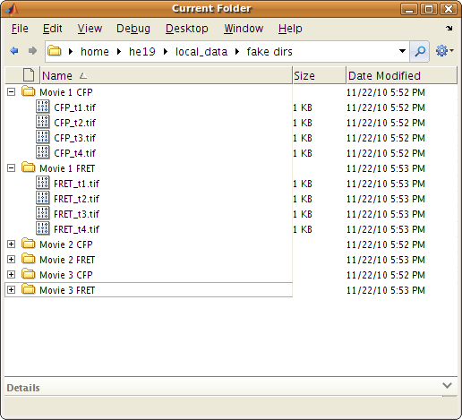

**If your data is not already in this format, don’t worry!** We have included some simple tools to make it easy for you to automatically put your data in this format. To learn how to use these tools, see the “Data Preparation” section of the “Advanced User” guide at the end of this document.

**Step 4 - Selecting Movies to Process:**

Before you can begin processing your data, you need to tell the software where the data is. This is done using the “Movie Selector.” To open the movie selector, type “movieSelectorGUI” at the Matlab command line (Fig. 2). Fig 3 shows the movie selector.

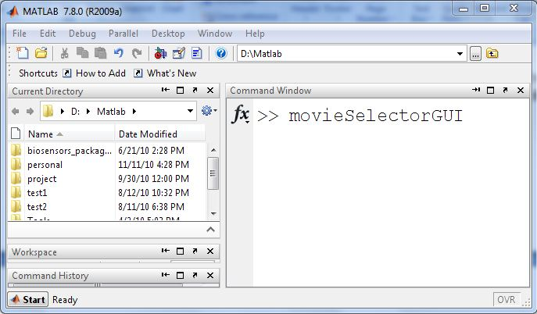

Figure 2: Open movie selector

Figure 3: Movie Selector

**If this is the first time you have selected this movie**, you will have to specify the directories containing the images for each channel of the movie. The locations of these directories, in addition to all the information regarding the processing of the movie, are stored in a file called the “movie data”. If this is the first time you have processed this movie, you will need to create a movie data file for it:

1. Click the “New” button to create new “movie data” (Fig 4)

Figure 4: Create New Movie Data

1. Define the required (and/or optional) parameters:

* **Input channels**: Here you can select folders containing the images for each channel of the movie. Each channel must be in a separate folder, with one file per time point ( See step 2 “Preparing your Data.”) Note that all channels should have the same number of images, and their images should all be the same size.
* **Output Path**: This specifies where the results of the processing will be stored.
* **Channel-specific Parameters** (optional): excitation wavelength, emission wavelength, exposure time. These parameters are not used by this package, but can be specified.
* **Movie Information** (optional ): pixel size, time interval, numerical aperature, camera bit depth. These parameters are not used by this package, but can be specified.
* **Notes** (optional). A note describing the condition, experiment number, the date, etc. - anything you want!

1. Click “Save”

**If you have selected or processed this movie before**, simply click the “Open” button and select the saved Movie Data or Movie Data List .mat file, then click “Ok”

Once the movies are selected, their directories will be displayed in the list box in Movie Selector Panel. By clicking “Save as Movie Data List” button; the current movies selected can be saved as a movie data list. The movie data list is saved in a MAT file. To load the same set of movies the next time, open the saved movie data list MAT file by clicking “Open” button. Note that movie data list only copies the directories of movie data instead of the movie data themselves.

Select “Biosensors Package” from the package list, and click “Continue” to begin processing your data.

**Step 5 – Process the Movie(s)**

You should now see a panel which looks something like this:

Figure 6: Biosensors Package Control Panel

You must now set up and run each step of the processing. If you are processing more than one movie, you may configure the settings on only the first movie and then run all movies with these settings. However, you *are* required to configure the settings for each step on at least the first movie. To run the processing steps:

1. Select checkboxes of the steps you would like to run. A step that depends on other step(s) cannot be selected until the step(s) on which it depends have been selected. See “Biosensors Package Workflow” above.
2. Configure the selected steps before running by clicking the "Setting" button next to the step, and then clicking “Apply” in setting panel.
3. Click “Run” - By default this will run all selected steps which have **NOT** yet been successfully run in only the **current movie**. Additionally, you may check these boxes:
4. “Force Run” checkbox - Re-run the steps which have been successfully run.
5. “Run all movies” - Run all checked steps in all movies (if more than 1 movie is loaded)
6. When a step has been completed, click the corresponding "Result" button to display the results of that step.

**Indicator icons** will appear next to steps once they have been run/attempted to be run:

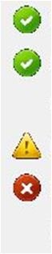

* The step has been processed successfully.
* There is a warning regarding this step. Click the icon for more information.
* There was an error and the step was not completed. Click the icon for more information.

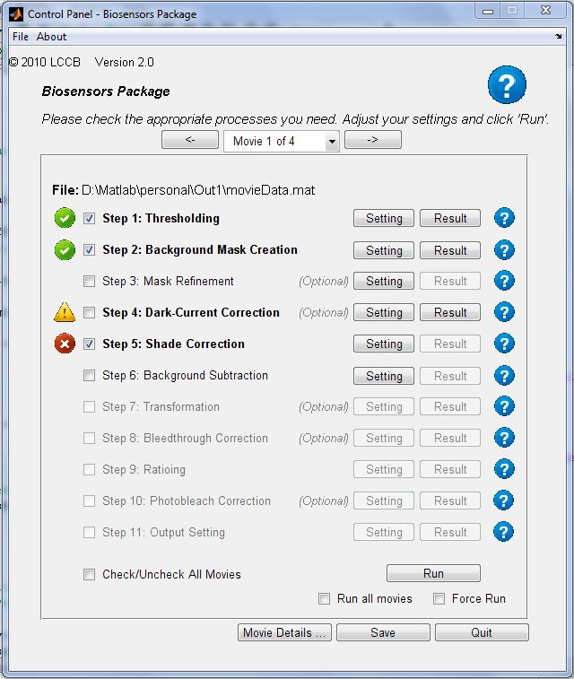**Help Icons** can be found throughout the software. Click on these icons to see help for the GUI as a whole, individual steps, and the settings for individual steps.

When you complete the final step, “Output” the fully-corrected ratio images will be saved to a directory as .tif image files, which can then be analyzed and displayed with other software. Because .tif files only store integer-valued images, the ratio images must be multiplied by a “scale-factor” first. It is important to use a consistent scale factor when comparing multiple images/experiments.

**Advanced User Guide**

This section describes how to use the portions of the package that are command-line only. That is, they do not have a graphical user interface and require typing commands at the Matlab prompt.

# Data Preparation

We have included several “data preparation” tools to rearrange your data files into the format expected by the software (See “Prepare Your Data” step above). These functions are listed here, along with brief descriptions. For more in-depth help, see the documentation of the function itself. This can be found by typing the name of the function into the matlab prompt and then pressing the F1 key, or by right-clicking on the function name and clicking “Help on Selection”

**separateNumberedFiles.m** – This function allows automatic separation of numbered files into individual directories. This is generally useful if you have multiple movies or channels stored in a single directory, and want to separate them for processing with the software.

For example, if your movies are numbered like this:

MyDirectory/Movie1_CFP_t1.tif

MyDirectory/Movie1_CFP_t2.tif

MyDirectory/Movie2_CFP_t1.tif

MyDirectory/Movie2_CFP_t2.tif

…

Then typing this command at the Matlab prompt:

separateNumberedFiles(MyDirectory,’Movie#’)

will separate each of the movies into its own sub-directory named “Movie1”, “Movie2” etc. After that, you can use the setupMovieImageFolders.m function to put each channel in its own directory (see description below).

**splitProjectMovieImages.m** – If your movie has multiple timepoints stored in a single file, for instance as a .STK file or a multi-page .tif file, this function allows you to automatically separate them into individual .tif files, one per timepoint. First, make sure each movie is in its own directory, then use this function to put each channel in its own directory, and split the big .STK or .tif file into smaller files with one per timepoint.

**setupMovieImageFolders.m** – If your movie has each timepoint from each channel as an individual file, but all the channels are in the same directory, you can use this function to separate each channel into its own directory. First, make sure the files for each move are in their own directory. Then, use this function to put each channel in its own directory.

# Alignment/Registration Transform Creation

Producing accurate ratio images requires that the images being ratioed are very well aligned, or “registered.” Misalignment is very significant when multiple cameras are used to acquire the different images, but can still be significant in single-camera applications. To align images from different channels, this software allows application of an “image transform.” However, the transformation must be determined beforehand. This is accomplished by taking registration images and then determining a transform from them.

Registration images are images of the same object taken in multiple channels. This is usually multi-spectral fluorescent beads, or a grid micrometer. Other images can be used, but is important to be sure that the *only* difference between what’s imaged in each channel is the alignment. For this reason, experimental images (eg images of cells, single-molecule FRET probes etc) are generally not acceptable.

**calculateMovieTransform.m** - Once the registration images have been taken, this function can be used to create and save a transform. This transform can then be used in the biosensors package to align the two channels the registration images came from. For more than two channels, multiple transforms may be needed. See the calculateMovieTransform.m help for more information on using the function.

# Bleedthrough Coefficient Calculation

When ratiometric biosensors are imaged, there is almost always some bleedthrough between the different channels. That is, the fluorescence in one channel shows up in the other channel, but to a lesser extent. With unimolecular biosensors, the two channels are perfectly co-localized, so the ratioing itself ‘cancels out’ the bleedthrough. With bi-molecular biosensors or with single-molecule imaging, the localization is rarely identical and therefore the bleedthrough must be corrected. However, before it can be corrected, bleedthrough coefficients must be determined, which describe the extent to which one channel bleeds into the other.

Bleedthrough coefficients can be determined by imaging only one of the two fluorophores in both channels. For example, to determine CFP to FRET bleedthrough, you would image only the CFP part of the biosensor, but you would take images in both the CFP *and* FRET channels.

**calculateMovieBleedthrough.m** – Once the bleedthrough images have been taken, this function can be used to calculate the bleedthrough coefficient for the sets of channels that were imaged. First, the movie must be arranged just as a normal biosensor movie would be before processing (see “Data Preparation” above). Then, a movieData file should be created for it using the movieSelectorGUI, as described above. Then, the move can be used to calculate a bleedthrough coefficient. See the calculateMovieBleedthrough.m documentation for more information.

# Movie Making

It is often useful to create .mov or .avi movies of the final ratio images for use in presentation, supplementary material etc.

**makeRatioMovie.m** – Once a movie has been fully processed, this function can be used to make a .mov (Quicktime) or .avi movie of the ratio images. See the function help for more information.

**makeMovieMovie.m** – This function can be used to make .avi or .mov movie file of the raw images for any movie channel, or of the results from any processing step. See the function help for more information.